JOINS FROM 1168 LINE
SELECT p.person_id,p.first_name,p.last_name,h.household_sub_token,h.household_size
FROM Person p INNER JOIN Household h ON p.household_id = h.household_id;
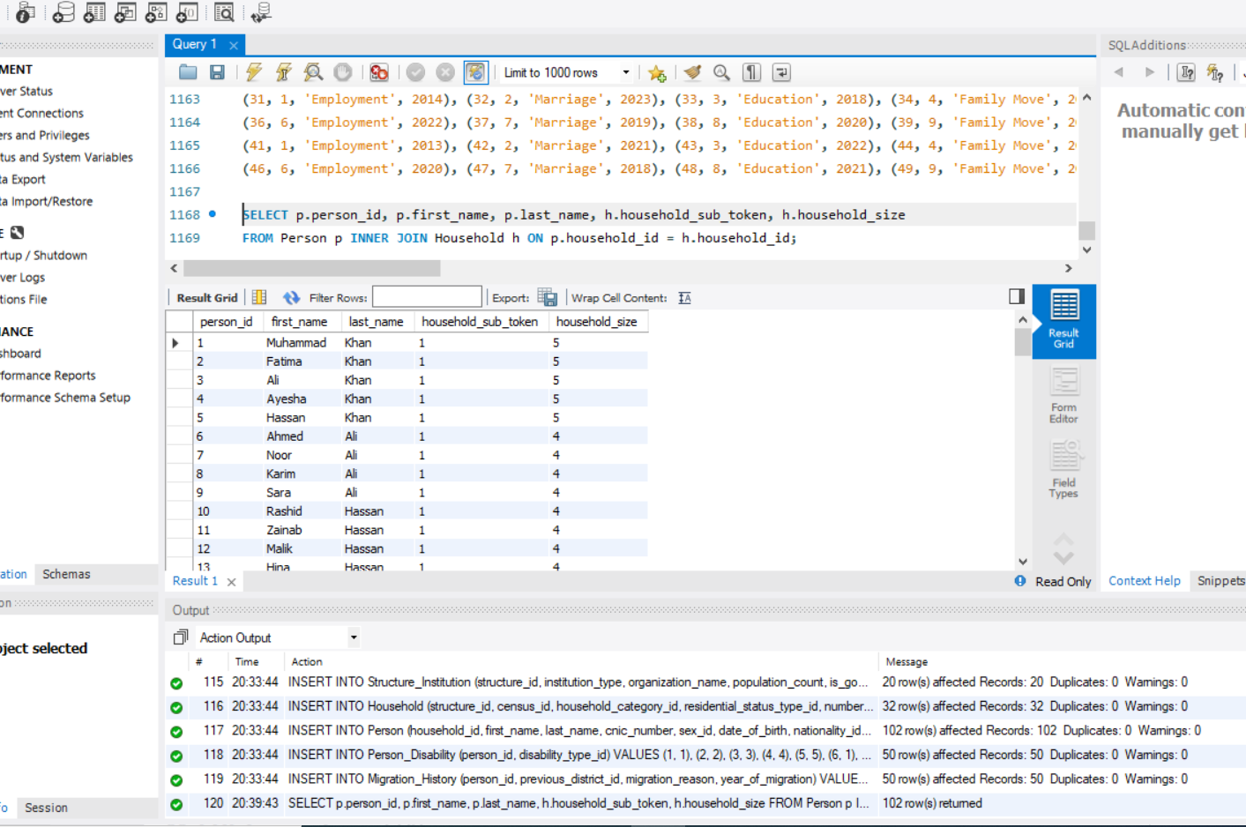
LEFT JOIN SELECT
p.person_id, p.first_name, m.migration_reason, m.year_of_migration FROM Person p LEFT JOIN Migration_History m ON p.person_id = m.person_id;
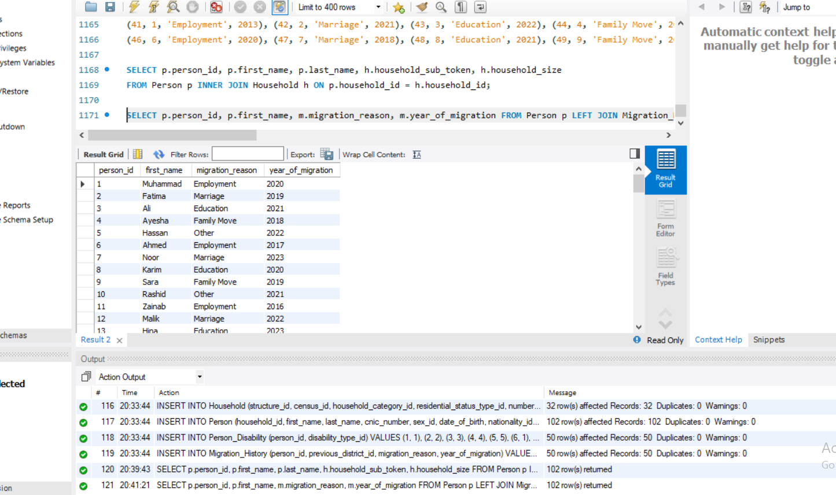
RIGHT JOIN
SELECT c.census_block_code, s.first_name, s.staff_role FROM Census_Staff s RIGHT JOIN Census_Block c ON s.assigned_census_block_id = c.census_block_id;
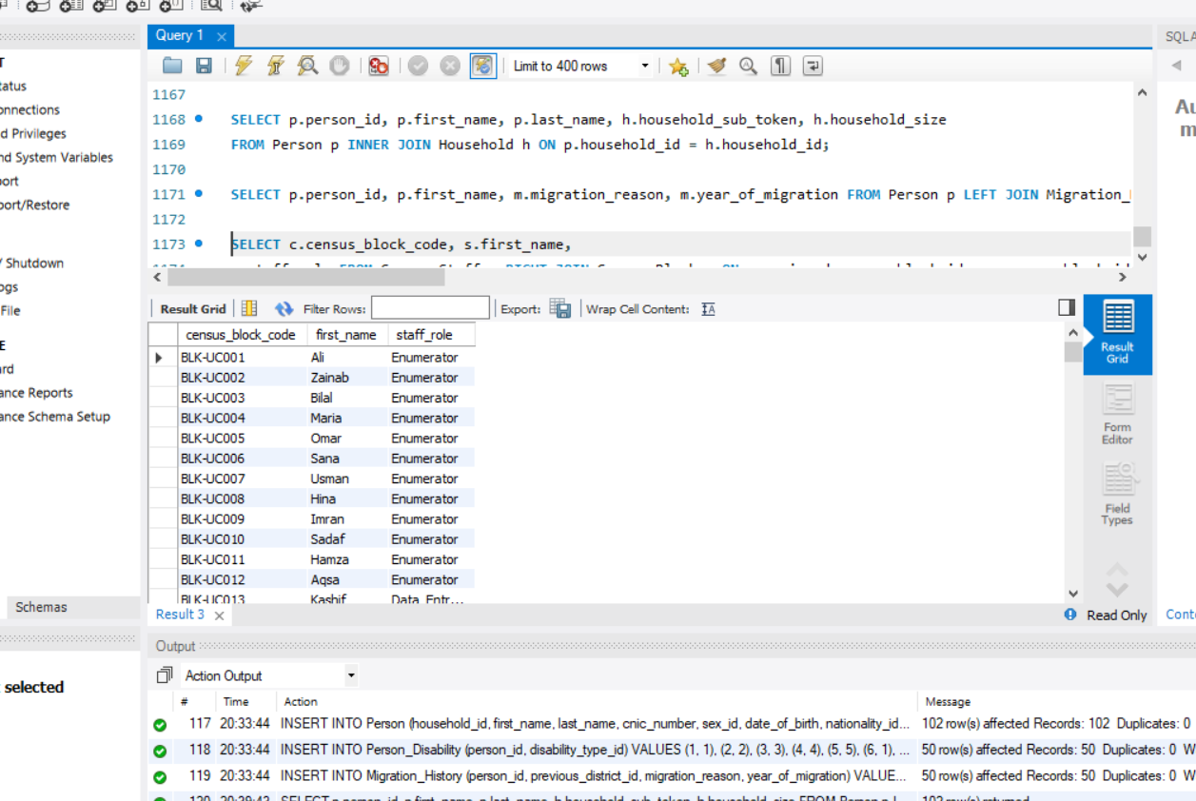

FULL OUTER JOIN
SELECT p.person_id, m.migration_reason FROM Person p LEFT JOIN Migration_History m
ON p.person_id=m.person_id UNION SELECT p.person_id,
m.migration_reason FROM Person p RIGHT JOIN Migration_History m ON p.person_id=m.person_id;

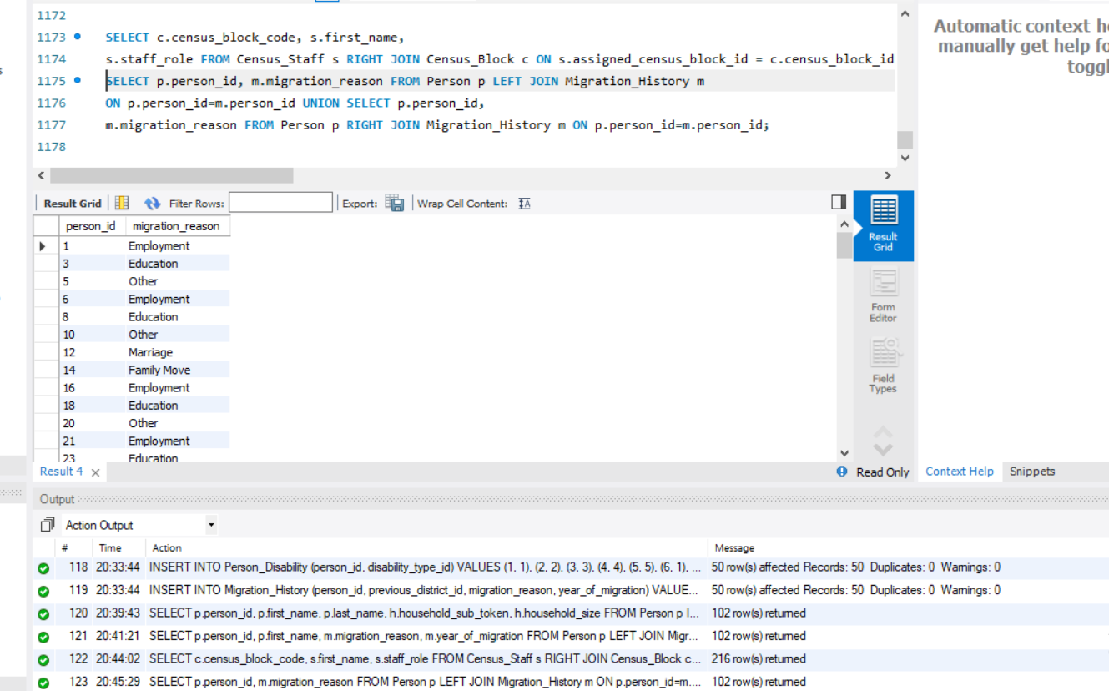

NATURAL JOIN
SELECT * FROM Occupation NATURAL JOIN ( SELECT occupation_id FROM Person ) A;
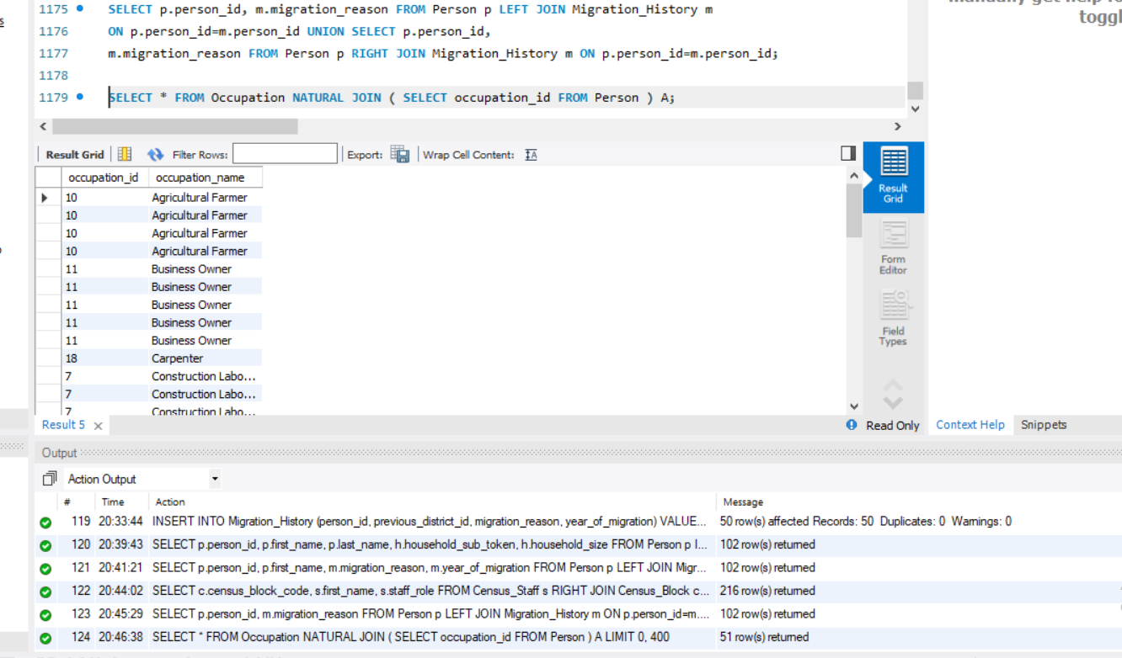
SELF JOIN
SELECT e.first_name AS Employee, s.first_name AS Supervisor
FROM Census_Staff e LEFT JOIN Census_Staff s ON e.supervisor_id=s.staff_id;
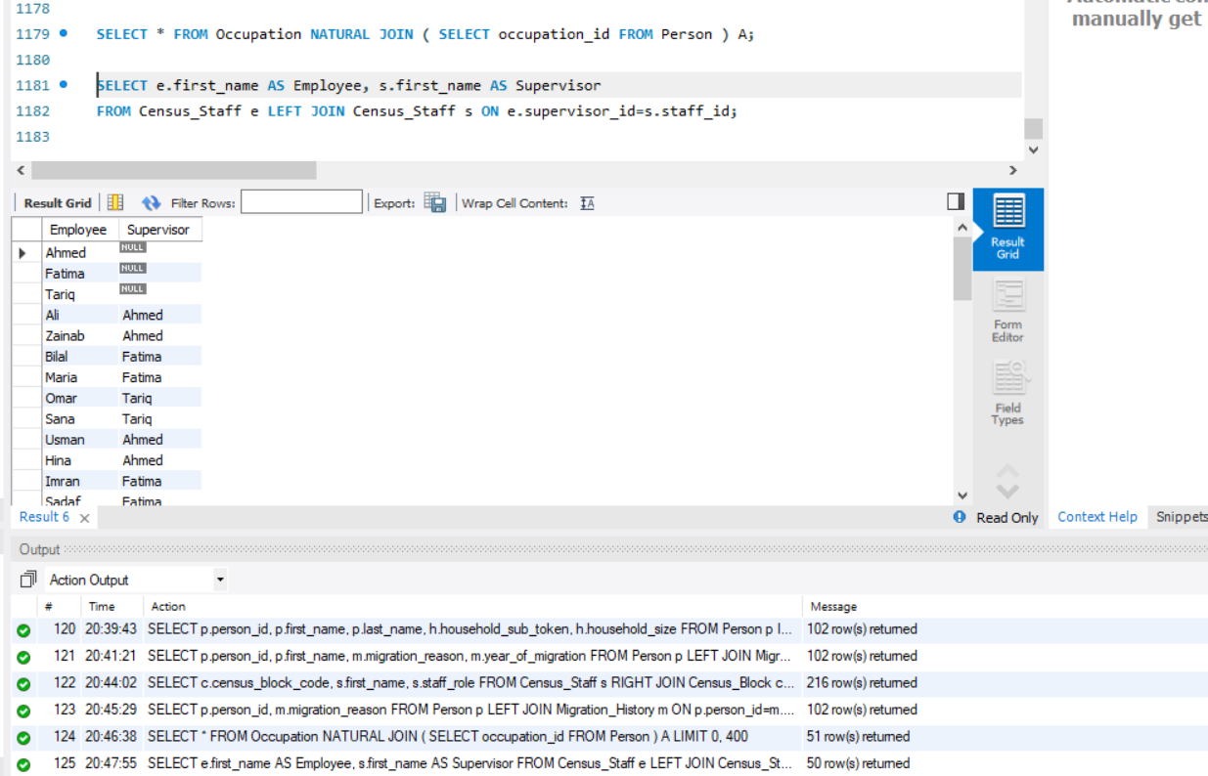

COMPLEX JOIN (FOUR TABLES )
SELECT p.first_name,p.last_name,h.household_sub_token,cb.census_block_code,uc.union_council_name
FROM Person p INNER JOIN Household h ON p.household_id=h.household_id
INNER JOIN Census_Block cb ON cb.census_block_id=h.household_id
INNER JOIN Union_Council uc ON cb.union_council_id=uc.union_council_id;

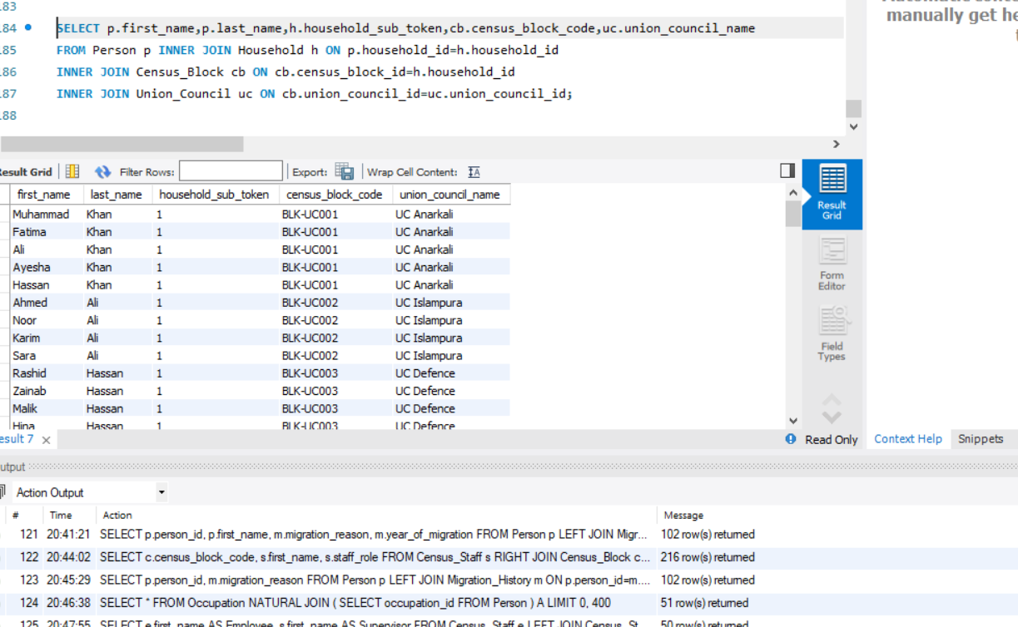

NESTED & CORRELATED QUERIES

1. IN
Persons from households having more than 5 members.
SELECT first_name,last_name
FROM Person
WHERE household_id IN
(
SELECT household_id
FROM Household
WHERE household_size > 5
);

2. ANY

SELECT first_name,monthly_income FROM Person
WHERE monthly_income > ANY (
SELECT monthly_income FROM Person WHERE sex_id=2
);
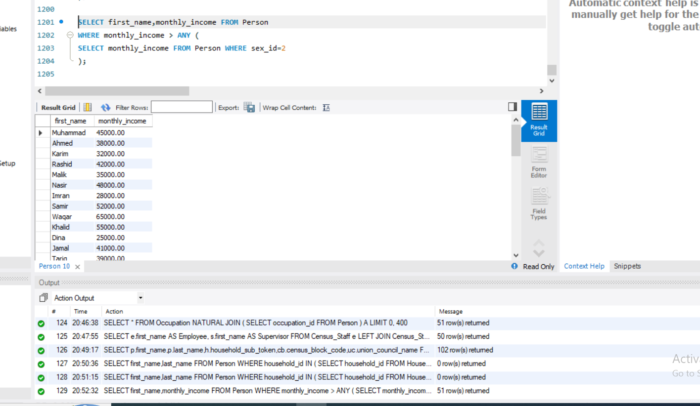

3. ALL
Income greater than ALL females.
SELECT first_name,monthly_income
FROM Person
WHERE monthly_income >
ALL
(
SELECT monthly_income
FROM Person
WHERE sex_id=2
);

4. NOT IN
Persons not migrated.

SELECT first_name
FROM Person
WHERE person_id NOT IN
(
SELECT person_id
FROM Migration_History
);
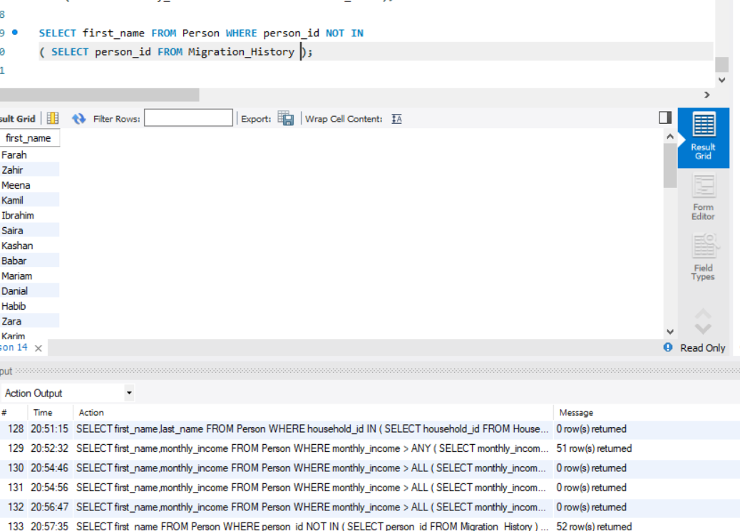

5. NOT ANY
Equivalent:
SELECT first_name
FROM Person
WHERE monthly_income <= ALL
(
SELECT monthly_income
FROM Person
WHERE sex_id=1
);
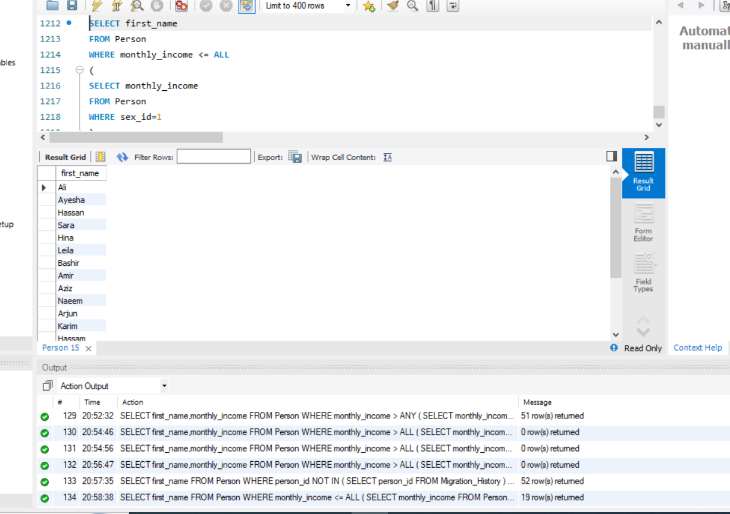

6. NOT ALL
SELECT first_name
FROM Person
WHERE monthly_income <= ANY
(
SELECT monthly_income
FROM Person
WHERE sex_id=1
);
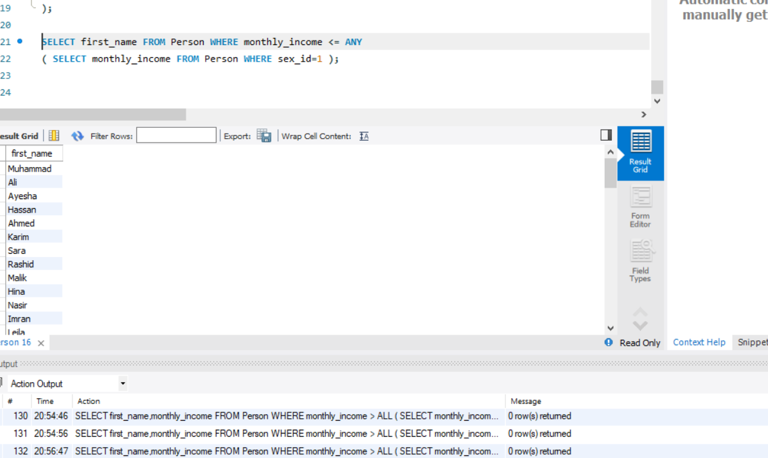

7. EXISTS
Persons having migration record.
SELECT p.first_name
FROM Person p
WHERE EXISTS
(
SELECT *
FROM Migration_History m
WHERE m.person_id=p.person_id
);

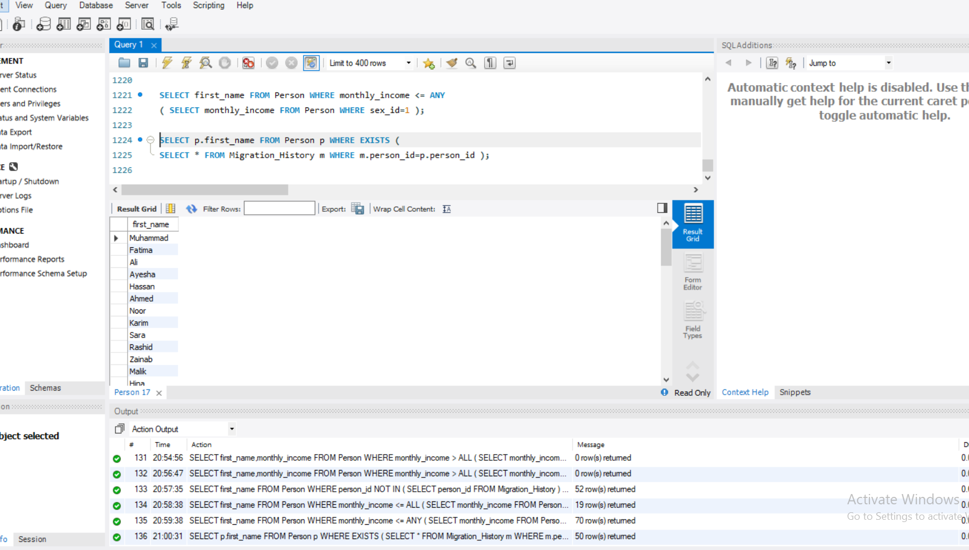

8. NOT EXISTS
Persons without migration.
SELECT p.first_name
FROM Person p
WHERE NOT EXISTS
(
SELECT *
FROM Migration_History m
WHERE m.person_id=p.person_id
);

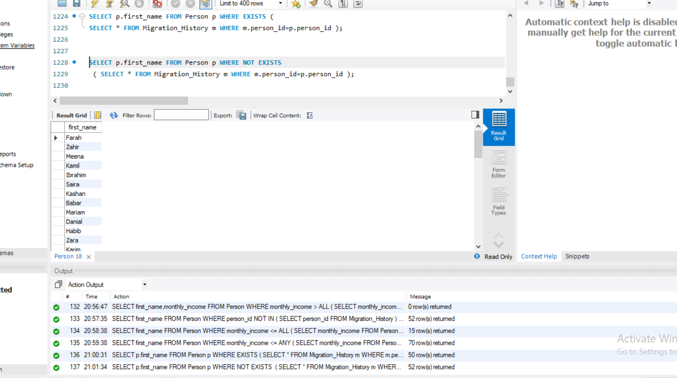

11C. AGGREGATE QUERIES

COUNT
Total population.
SELECT COUNT(*) AS TotalPopulation
FROM Person;

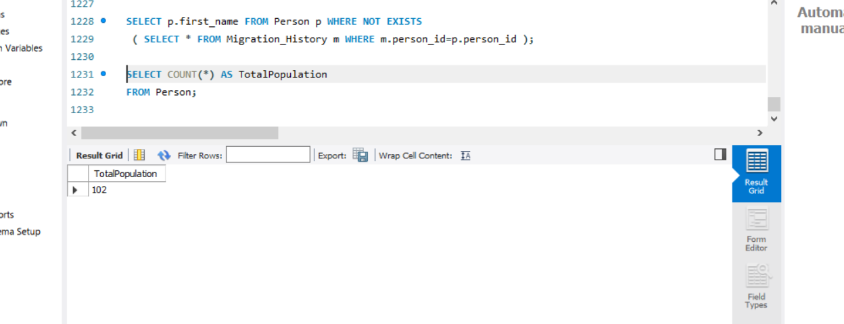

SUM
Total income.
SELECT SUM(monthly_income) AS TotalIncome
FROM Person;
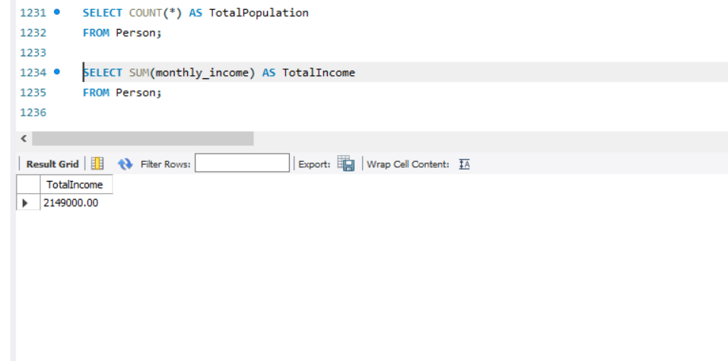

AVG
Average income.
SELECT AVG(monthly_income) AS AverageIncome
FROM Person;
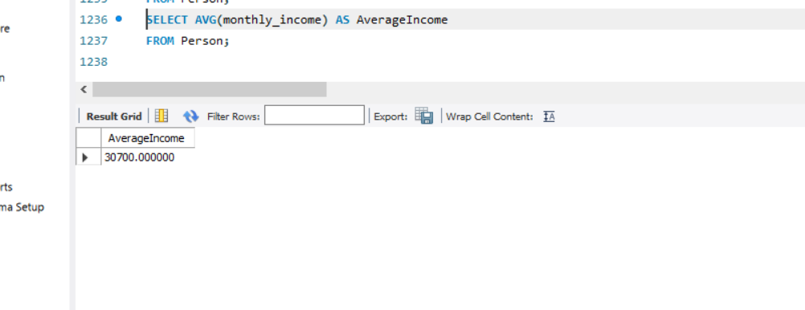

MIN
Lowest income.
SELECT MIN(monthly_income) AS LowestIncome
FROM Person;
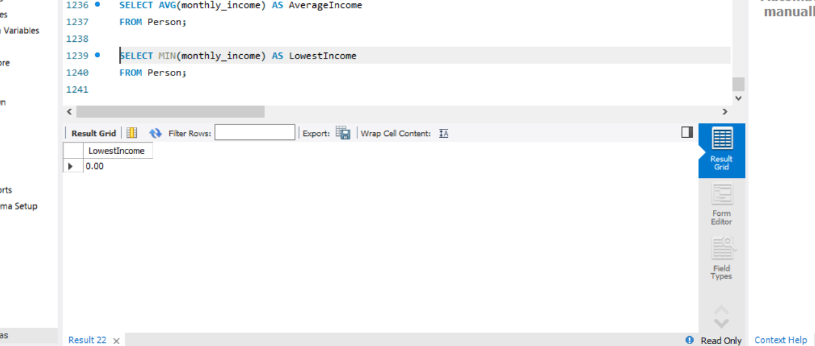

MAX
Highest income.
SELECT MAX(monthly_income) AS HighestIncome
FROM Person;
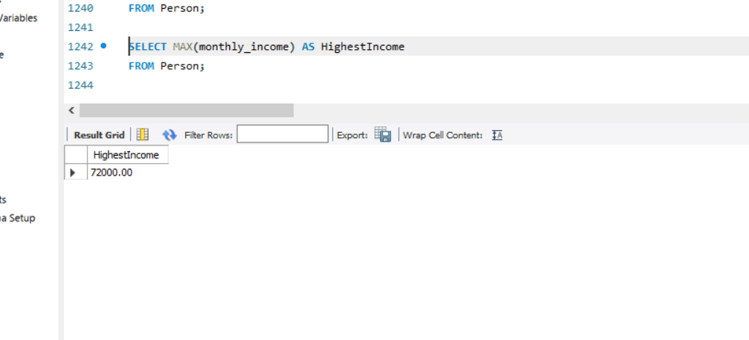

GROUP BY
Population by sex.
SELECT
b.sex_name,
COUNT(*) AS Population
FROM Person p
INNER JOIN Biological_Sex b
ON p.sex_id=b.sex_id
GROUP BY b.sex_name;
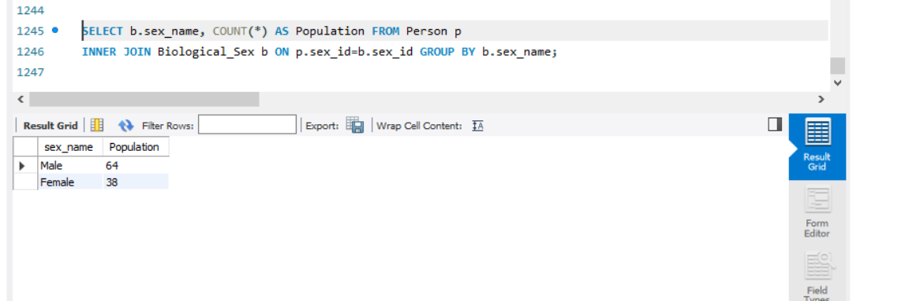

HAVING
Only groups with more than 3 persons.
SELECT
sex_id,
COUNT(*) AS Population
FROM Person
GROUP BY sex_id
HAVING COUNT(*) > 3;

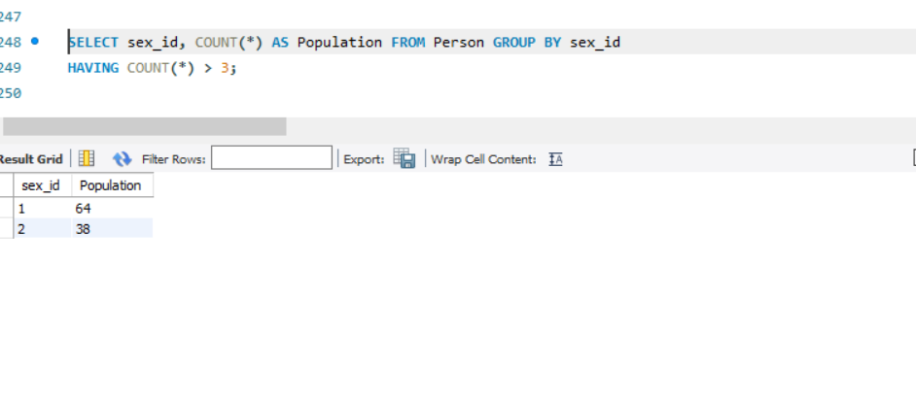

More Advanced Aggregate
SELECT
r.religion_name,
COUNT(*) AS Population,
AVG(monthly_income) AS AvgIncome
FROM Person p
INNER JOIN Religion r
ON p.religion_id=r.religion_id
GROUP BY r.religion_name;
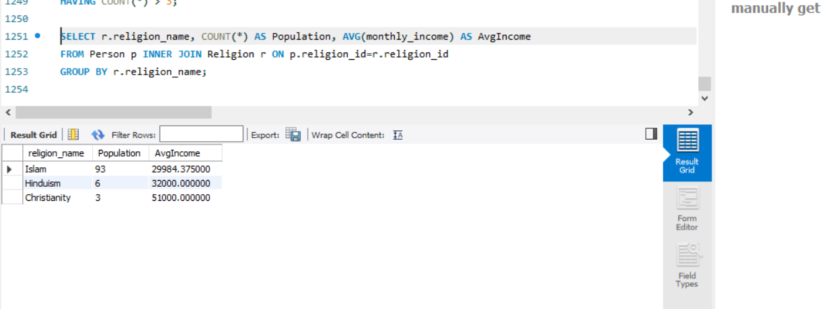

11D. SET OPERATIONS

UNION
All names from Persons and Staff.
SELECT first_name
FROM Person
UNION
SELECT first_name
FROM Census_Staff;
Removes duplicates.
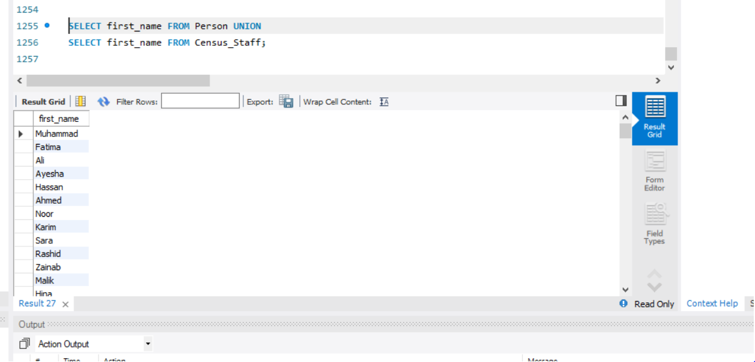

UNION ALL
SELECT first_name
FROM Person
UNION ALL
SELECT first_name
FROM Census_Staff;
Keeps duplicates.
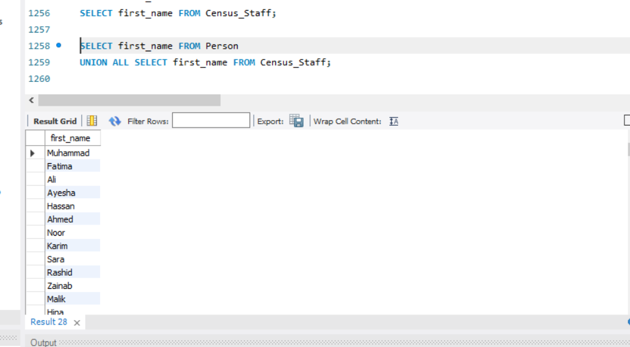

INTERSECT (MySQL Alternative)
SELECT first_name
FROM Person
WHERE first_name IN
(
SELECT first_name
FROM Census_Staff
);
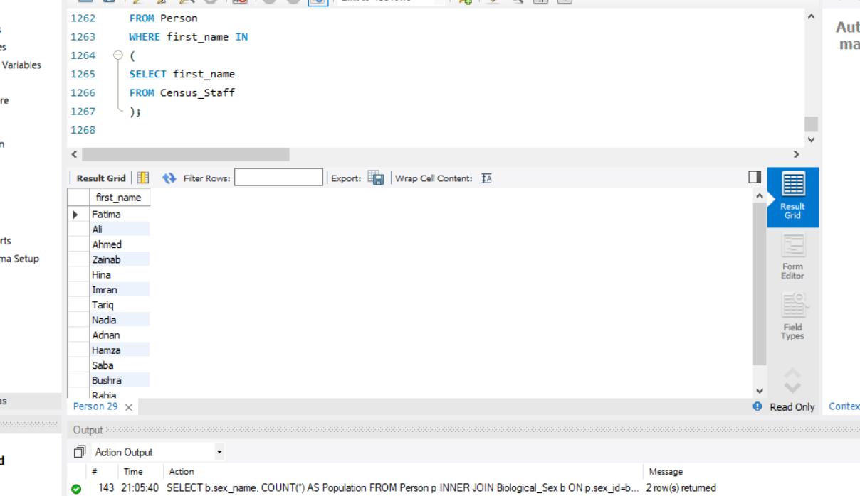

EXCEPT / MINUS (MySQL Alternative)
SELECT first_name
FROM Person
WHERE first_name NOT IN
(
SELECT first_name
FROM Census_Staff
);

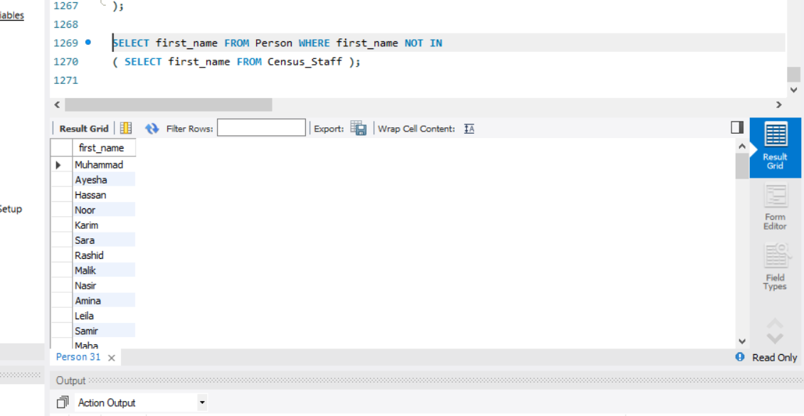

12. VIEWS

View 1 : Population Summary
CREATE VIEW vw_population_summary AS
SELECT
person_id,
first_name,
last_name,
monthly_income
FROM Person;
Usage:
SELECT * FROM vw_population_summary;
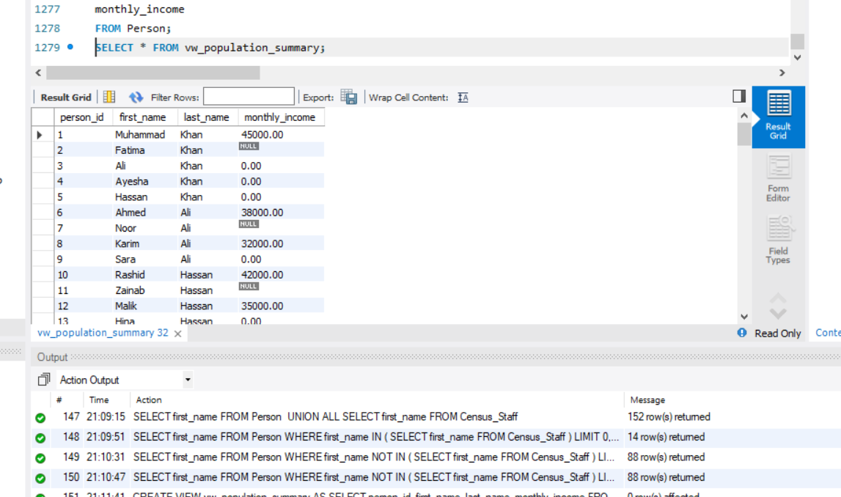

View 2 : Census Staff Assignment
CREATE VIEW vw_staff_assignment AS
SELECT
s.staff_id,
s.first_name,
s.last_name,
c.census_block_code
FROM Census_Staff s
INNER JOIN Census_Block c
ON s.assigned_census_block_id=c.census_block_id;
Usage:
SELECT * FROM vw_staff_assignment;

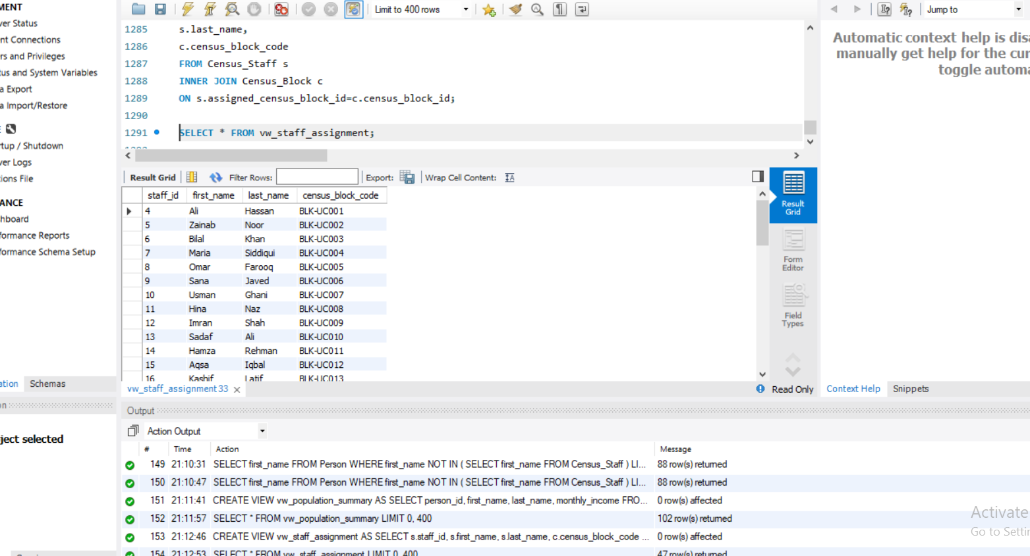

View 3 : Structure Information
CREATE VIEW vw_structure_details AS
SELECT
st.structure_id,
st.structure_address_no,
cb.census_block_code
FROM Structure st
INNER JOIN Census_Block cb
ON st.census_block_id=cb.census_block_id;
Usage:
SELECT * FROM vw_structure_details;
